Day | Activity | Venue | Time | Contact
Monday | Deckchair Care welcome café  Come and join us for some fun, rest and relaxation | Elm Road Church Halls  Elm Road, Gatley,  SK8 4LY | 1pm-3pm | Deckchair Care  0161 327 2894 | 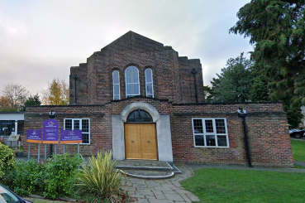
Monday  Free to attend | Memories Lane Café  Come along and enjoy complimentary coffee and cake. Chat with friends old and new and join in with fun activities | Bramhall Methodist Church, 23 Bramhall Lane South, Bramhall, Stockport, SK7 1AL | Every Monday 2-4pm | Able Care Living  0161 204 7968 | 
Monday  Free to attend | Upper Room drop-in café  Drop-in session to support each other, offer guidance and meet new people. Drinks can be bought from the cafe | Upper Room Café  11 Wilmslow Road, Cheadle, SK8 1DW | Every Monday  11am-1pm | Wellbeing Network team on 0161 804 4416 | 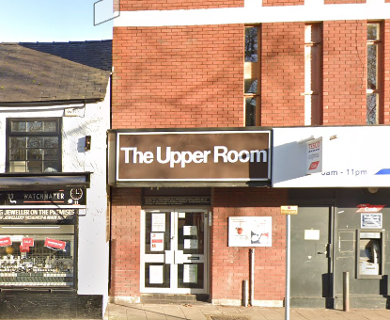
Monday | Morrisons Café meet  Come along for a chat and a cuppa | Morrisons’ Café,  Edgeley Road, Cheadle Heath, Stockport,  SK3 0TQ | Every Monday  1pm-3pm | Home Instead  0161 480 0646 | 
Tuesday  Free to attend.  Drinks/food can be purchased | Platform 5 Group  Carers and cared for support group. A friendly get together, talking, singing, and dancing.  Arts crafts, dominoes. | Platform 5  47 Station Road  Cheadle Hulme  SK8 7GH | Every Tuesday  11.30am – 2.30pm | Emma Driver 07584 281586 | 
Tuesday  Free to attend. Drinks/light snack provided | D Café  A friendly get together. Puzzles and games available or just a chat in a warm space. | Edgeley Community Church  Entrance via Old Chapel Street  Edgeley SK3 9JL | Every Tuesday  10am – 12pm | Mike Aspinall 07929 525909  barbara.aspinall@hotmail.com | 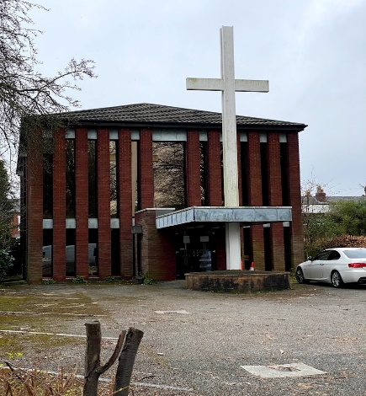
Wednesday  £4.00 per person, this includes lunch | RE: DISH Dementia Friendly Café  A friendly get together for people with dementia, their family, carers and friends. Price includes lunch | The Tapestry at St Agnes Church, Off Gorton Road,  North Reddish, SK5 6RA | 12pm – 2pm | Alison on 07540 792409 | 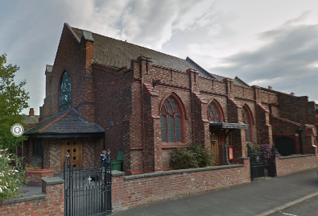
Wednesday | Stepping Hill Dementia Drop In  Jacky Smith, volunteer from the Alzheimer’s Society will be available in the lounge for a chat, advice, support and signposting. | The Serenity Lounge, Stepping Hill Hospital  Poplar Grove, Hazel Grove, Stockport SK2 7JE | 9am- 12pm | Alzheimer’s society  0161 477 6999 | 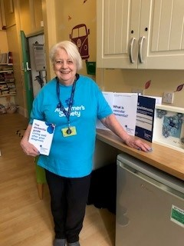
Wednesday  Session costs £2.50 per person | Alzheimer’s Society Singing for the Brain  A friendly get together for people with dementia, carers, friends; sing along to your favourite songs. | Short Street United Reformed Church, Hazel Grove Stockport SK7 4AD.  Parking available. | Second and fourth Wednesday of the month 2pm-3.30pm | For more information, please contact Alzheimer’s Society 0161 477 6999 or email stockport@alzheimers.org.uk | 
Wednesday  Virtual attendance free to attend | Alzheimer’s Society Greater Manchester Virtual Singing for the Brain Group Our virtual singing group is for people living with dementia and their family, friends, and carers. Hosted by Alzheimer’s Society staff and led by a friendly and enthusiastic musician over Zoom | Virtual over Zoom | First and third Wednesday of the month 2pm – 3:30pm | For more information, please contact Alzheimer’s Society 0161 477 6999 or email stockport@alzheimers.org.uk | 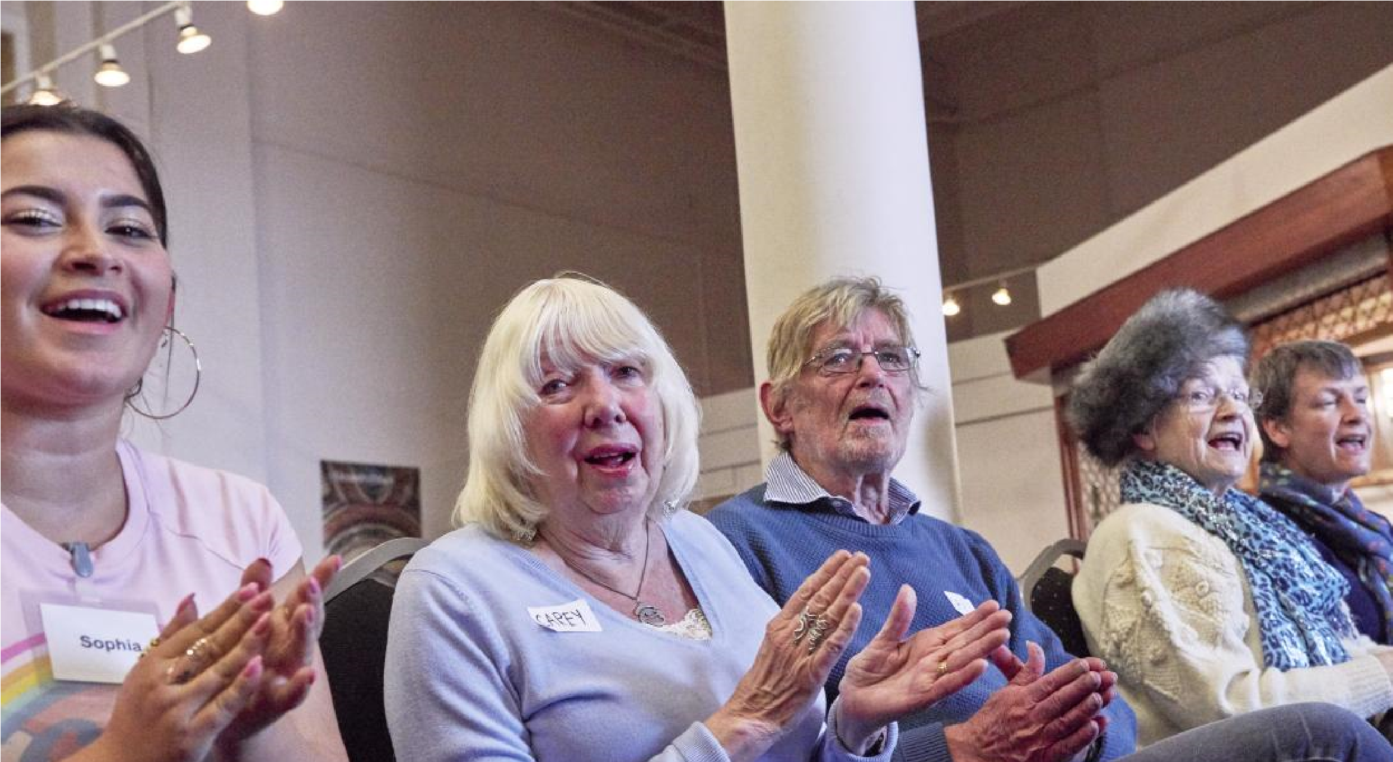
Wednesday  £2.50 per session | Singing for Memory  A new group to meet and sing with people in a fun and social environment for anyone living with memory loss | Offerton Community Centre, Mallowdale Road, Offerton, SK2 5NX | Every Fortnight on Wednesday, speak to Louise Evans (Contact) for date of next session  10:45am-12:15pm | Stockport Homes  Louise Evans  07875 990222  Louise.evans@stockporthomes.org | 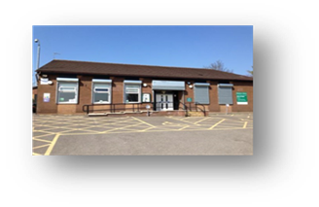
Thursday  Free to attend.  Drinks/food can be purchased | Platform 5 Group  Carers and cared for support group. A friendly get together, talking, singing, and dancing.  Arts crafts, dominoes. | Platform 5  47 Station Road  Cheadle Hulme  SK8 7GH | Every Thursday 12 noon – 2.30pm | Emma Driver 07584 281586
Thursday  Free to attend  Drinks can be bought from the café | ROMILEY Drop in Café Nibble & Natter  For people living with dementia, their family, carers & friends. | Romiley Life Centre,  3 Stockport Road,  Romiley, SK6 4BN | 3pm – 4pm | Margaret 0161 406 6729 | 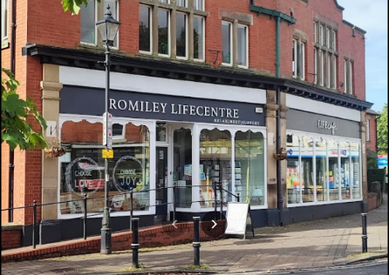

Day | Activity | Venue | Time | Contact
Friday  Free to attend  Hot & cold drinks at the bar | The MARPLE Drop In.  A friendly group organised by Dementia Friendly Marple and EDUCATE | Marple Cricket Club,  Bowden Lane, Marple.  SK6 6LJ | 11.30am – 1.30pm | info@marpledementiadropin.org  0161 414 0160 | 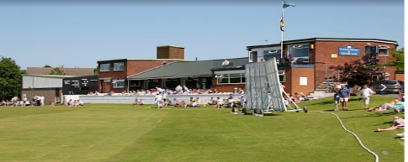
Friday | Stepping Hill Dementia Drop In  Jacky Smith, volunteer from the Alzheimer’s Society will be available in the lounge for a chat, advice, support and signposting. | The Serenity Lounge, Stepping Hill Hospital  Poplar Grove, Hazel Grove, Stockport SK2 7JE | 9am-3.30pm | Alzheimer’s Society  0161 477 6999
Friday  May be spaces available, please contact the organiser | Fridays in HEATON MOOR  A friendly get together for people with dementia accompanied by their carer, a family member or friend. This group is operated by Dementia Friendly Heaton’s | Heaton Moor United Church, Stanley Road,  Heaton Moor, SK4 4HL | 1.30pm – 3.30pm | dementiafriendlyheatons@gmail.com  Contact: JoAnne on 07340 269354 | 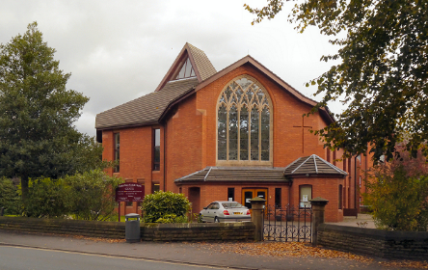
Friday | Musical Memories  We are a group who have always loved playing music and singing together and started Musical Memories to create social singing sessions to help bring people of all ages together for the simple pleasure of singing, talking, remembering, and enjoying  each other’s company – not to mention the cuppa and biscuits!  Open to those “with or without Dementia” | Woodley Methodist Church, Chapel Street, Woodley, Stockport,  SK6 1NF | Last Friday of the month  2pm – 4pm | Phil Taylor on  0161 430 8518  philip.taylor13@yahoo.com | 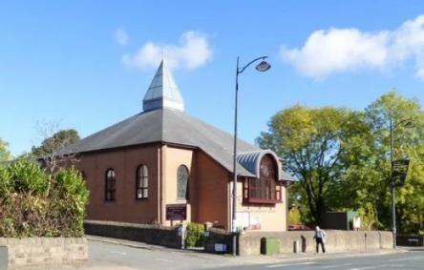
Saturday  Open to all and family and friends  Free hotpot, tea, coffee, and squash | Dementia Disco  Music to inspire Memory, conversation, and friendship. Lovely warm and welcoming atmosphere | Ladybridge Residents Club, Edenbridge Road, Cheadle Hulme, SK8 5PX | 5pm-7pm  Second Saturday of every month | dementiadisco@gmail.com | 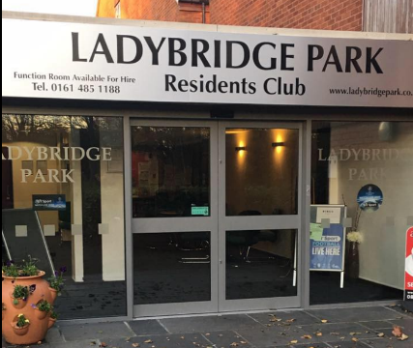
Saturday  Open to all and family and friends  Free hotpot, tea, coffee, and squash | Dementia Disco  Music to inspire Memory, conversation, and friendship. Lovely warm and welcoming atmosphere | Heaton Mersey Conservative Club  444. Didsbury Road Stockport, SK43BS | 5pm-7pm  Fourth Saturday of every month | dementiadisco@gmail.com | 

