Delirium free in-person workshop for family members
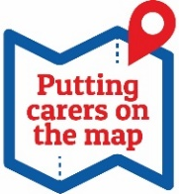
Dementia United in partnership with the African Caribbean Care Group are delivering the workshop alongside carers with lived experience.
Wednesday 12th June 12.30-4pm
During Carers Week 2024

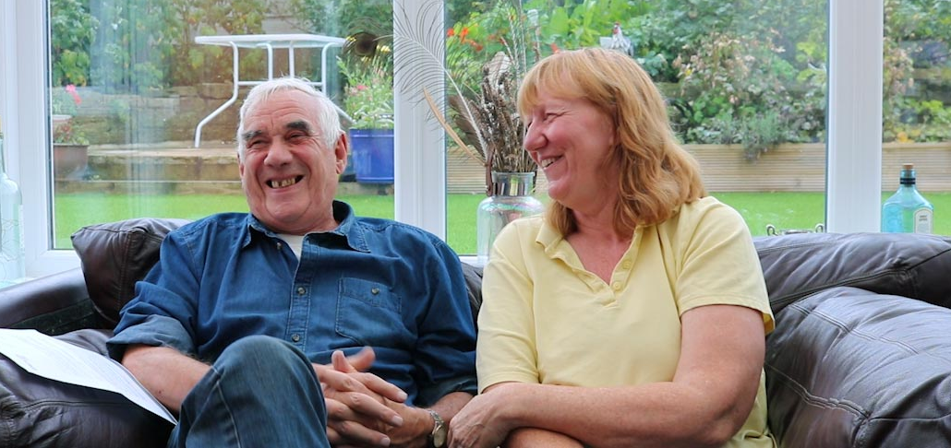
Delirium causes a short term confused state and can develop over hours or days. It is a sign of an underlying illness. Older people and people with dementia are at greater risk of developing delirium.
Open to family members of any background  Location The African Caribbean Care Group, Claremont Centre, 2 Jarvis Road, Manchester, M15 5FS | The workshop will cover:  - What is delirium?  - How to prevent delirium  - Identifying the causes and signs  - Getting help when you need it
To sign up please email gmhscp.dementiaunited@nhs.net
There are limited places available, so please sign up early!

How to find the ACCG
Address
African Caribbean Care Group
Claremont Centre
2 Jarvis Road
M15 5FS
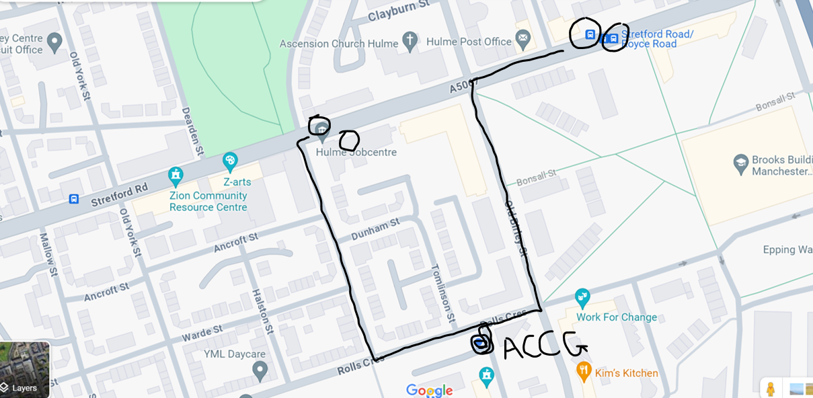
Buses to the ACCG from the city centre
86, 250, 253, 256.
Other buses
53, 263
We are located just behind Hulme Garden Centre, next to Rolls Crescent Primary School
For drivers
There is a car park at the Claremont Centre, however due to ongoing construction work there may be limited spaces. There is also roadside parking that is available for up to 2 hours.
Please note we will only be providing refreshments - feel free to bring your lunch!
For more information
See the Dementia United www.dementia-united.org.uk/news/2024/02/22/delirium-top-tips-for-carers-and-family-members
You can find out more about our delirium programme here www.dementia-united.org.uk/delirium/
Any questions email gmhscp.dementiaunited@nhs.net

