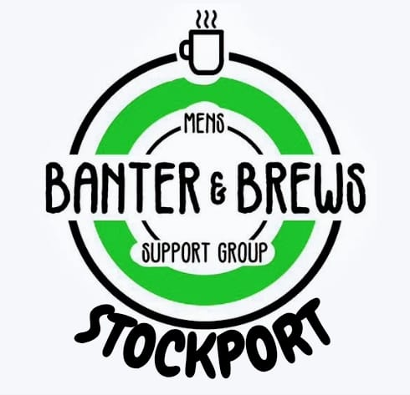

**Banter and Brews Events News: on Monday Evening 7 till 9pm & Thursday Afternoon - 12:30 till 2:30pm At Life Leisure Brinnington:**

**Starting: - April 2025 - (Open to all men – 18+):**

**Thu - Activity Afternoons**:

Healthy Soups: Baked Potatoes: Fresh Fruit:

Outdoor Walking Football:

Chair Exercise:

Gym Sessions, with Qualified Life Leisure Trainer:

`

**Mon - Games and Food Nights**.

Poker & Pies:

Cards Curry:

Bingo & Baps:

Pool and Darts Competitions:

